APSC 278 Notes
Christopher Kalitin - 25W2

Lectures

Jan 7 (L2) Atomic Structures and Interatomic Bonding
Jan 9 (L3) Crystal Structures I
Jan 12 (L4) Crystal Structures II
Jan 14 (L5) Imperfections in Solids
Jan 16 (L6) Mechanical Properties of Materials I - Elasticity
Jan 19 (L7) Mechanical Properties of Materials II - Tensile Test & Plasticity
Jan 21 (L8) Mechanical Properties of Materials III - Hardness and True Stress-Strain
Jan 23 (L9) Dislocations and Strengthening Mechanisms I
Jan 26 (L10) Dislocations and Strengthening Mechanisms II
Jan 28 (L11) Failure of Materials I
Feb 4 (L12) Failure of Materials II
Feb 6 (L13) Failure of Materials III
Feb 9 (L14) Failure of Materials IV
Feb 11 (L15) Phase Diagrams I
Feb 13 (L16) Phase Diagrams II
Feb 23 (L17) Phase Diagrams III
Feb 25 (L18) Process of Metal Alloys I
Feb 27 (L19) Processing of Metal Alloys II
Mar 2 (L20) Ceramics I
Mar 4 (L21) Ceramics II
Mar 6 (L22) Composites I
Mar 9 (L23) Composites II
Mar 11 (L24) Composites III
Mar 13 (L25) Polymers I
Mar 18 (L26) Polymers II
Mar 20 (L27) Polymers III
Mar 23 (L28) Corrosion and Degradation of Metals I
Mar 25 (L29) Corrosion and Degradation of Metals II
Mar 27 (L30) Corrosion and Degradation of Metals III
Mar 30 (L31) Electrical Properties I
Apr 1 (L32) Electrical Properties II

Jan 7 (L2): Atomic Structures and Interatomic Bonding

Atomic number = Z = num protons

Electrons have discrete energy levels! (shells)

Valence + Conduction band electrons

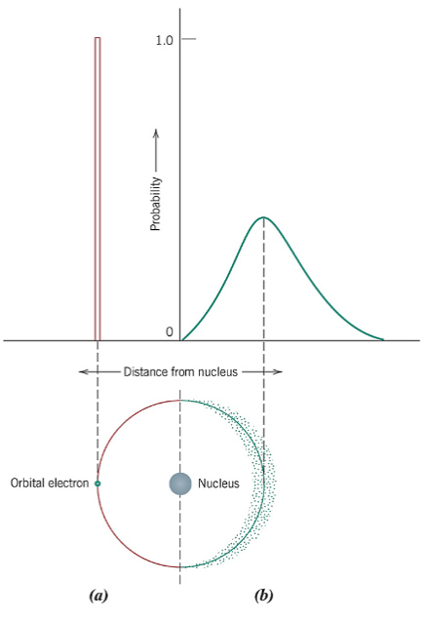
A = bohr model
B = wave-mechanical model, quantum distribution(?)

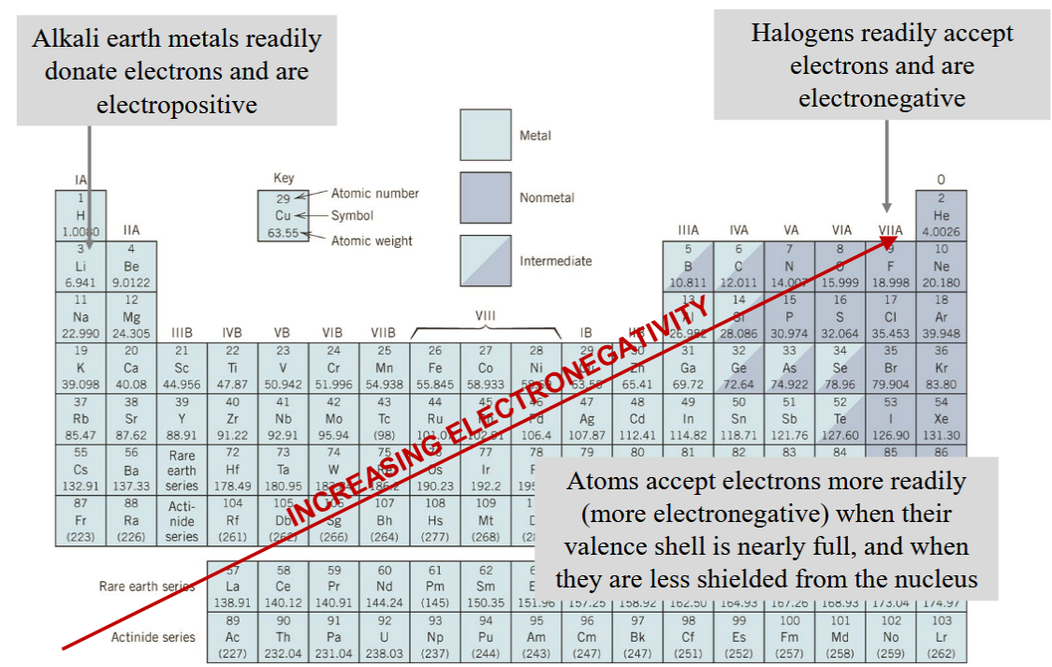

Electronegativity increases to the top right, which makes sense because of Oxygen and Fluorine (they like electrons, ie. oxidation).

Consider 2 atoms approaching each other.
They experience attractive and repulsive forces.

Attractive forces = bonds
Repulsive forces = electron shells repulsing each other

You get an equilibrium distance when net force is zero.

Ion = particle with charge

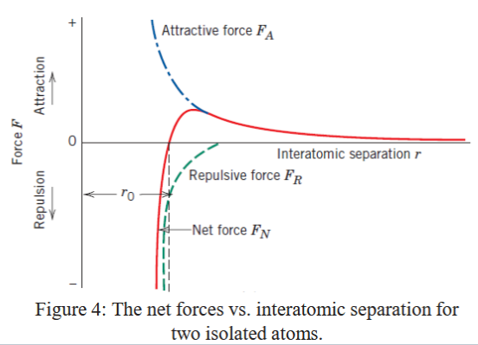

The equilibrium occurs when the red line is at 0, F_net = 0.

We can also plot energy:
(Equilibrium at minimum energy)
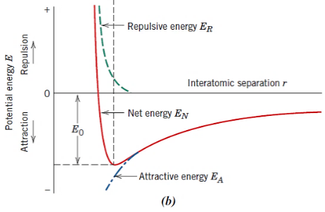

Bonding energy (E₀) represents energy required to put them infinitely far away from each other.

The curve of the above graph varies with material.

More negative E⁰ = Stronger bond

Primary bonds (intra-molecular / chemical bonds, all involve valence electrons):
- Ionic
- Covalent
- Metallic

Secondary bonds (inter-molecular, or physics bonds):
- Van der Waals bonds
- Hydrogen bonds

Ionic:
- Metal atoms give up their valence electron to the non-metal
- High bond energy, 600-1500 kJ/mol
- Bond energy directly related to melting temperatures!!!
- Eg. ceramic materials. Hard, brittle, electrically and thermally insulating (fewer conduction band electrons!)
- Non-directional, as electrostatic forces are uniform in all directions between the two atoms in an ionic bond

Covalent:
- For materials with smaller differences in electronegativity (than ionic)
- Share valence electrons
- Full range of strengths (Diamond, >3550 C melting point or Bismuth, 270 C melting point)
- Diamonds strong due to tetrahedral structure of carbon atoms (same but hexagonal sheets for graphite)
- Covalently bonded materials are electrical insulators or semiconductors.

Note: Some materials have covalent bonds in their natural state. Eg. A diamond crystal is just many covalent bonds.

Metallic:
- For metals and their alloys
- Metal atoms give up valence electrons, electrons float between atoms
- Good heat and electrical conductors

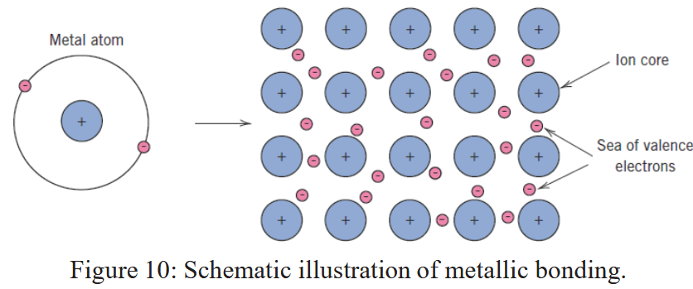

Van der Waals:
- Exist between everything
- Weakest type of secondary bonding (4-30 kJ/mol)
- They induce dipoles in each other
- Eg. Dipole atom + electrically symmetric atom, the dipole atom induces a dipole on the other
- This happens randomly as atoms float past each other

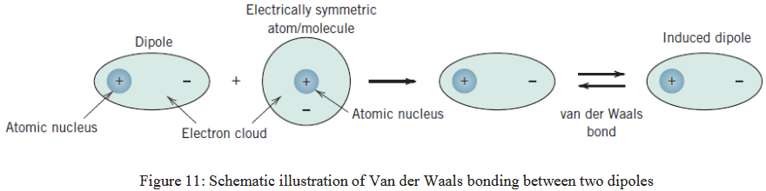

Hydrogen Bonds:
- When H is covalently bonded to NOF
- Asymmetric distribution of charge on NOF and H causes poles
- HF, NH3, H2O have high melting and boiling points due to strong hydrogen bonds

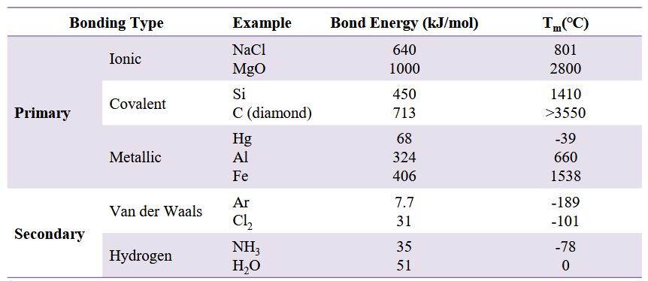

Bond + Material Classes!
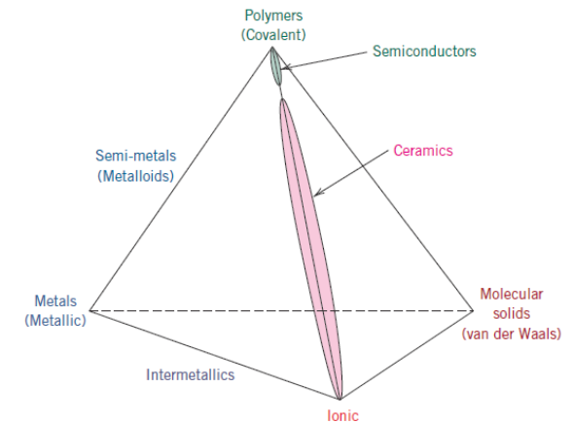

Fun! (not the prof)

Jan 9 (L3): Crystal Structures I

https://gemini.google.com/u/2/app/cb7b4e75ec2cf51f?pageId=none

Crystalline material = periodic repeating structure

Amorphous = absent atomic order

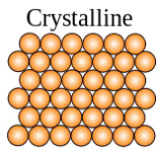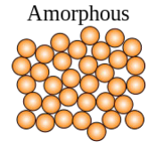

Unit Cell = basic structural unit of a crystal structure

This is a lattice, 3D array of points showing atomic positions.

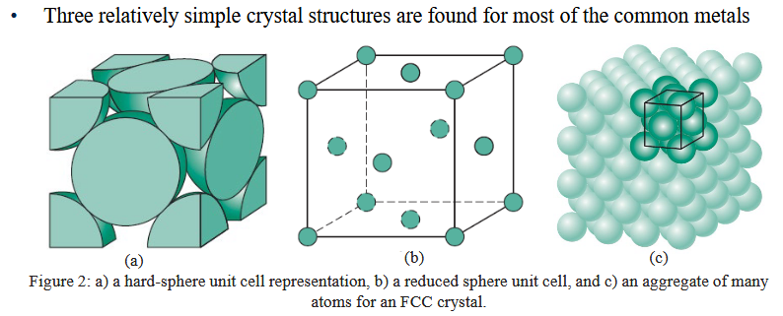

N = number of atoms per unit cell:

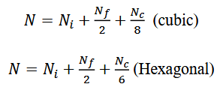

Unit cell length (a) is given in terms of atomic radius (R).

Coordination number:
number of nearest-neighbor (touching) atoms in a unit cell.

Close-packed directions:
Directions within a unit cell with highest linear density

Atomic Packing Factor:
Volume of atoms over volume of unit cell
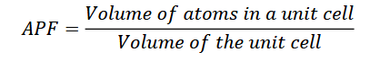

Face centered cubic (shown above too):
Copper, aluminum, silver, gold.
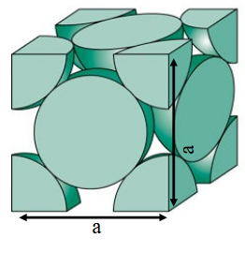

FCC (Face centered cubic):
- 4 atoms contains (6 faces / 2 + 8 corners / 8 = 4)
- Coordination number = 12.
  - Look at any atom and count how many other atoms it’s touching.
  - Note this is specific to an atom, not the unit cell.

To find unit cell length:
- Atoms packed on diagonals
  - So, find radii on a diagonal (4R)
- To find side length, pythagorean theorem
  - a² + a² = (4R)²
  - 2a² = 16R²
  - a² = 8R²
  - a = 2 * sqrt(2) * R²
  - 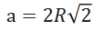

Atomic Packing Factor (APF):
- a = 2Rsqrt(2)
  - => V = (2sqrt(2)R)^3 = 22.627, given R = 1
- Volume of 4 atoms (given R = 1):
  - 16.76
- APF = 16.76 / 22.627 = 0.74

Body Centered Cubic (BCC):
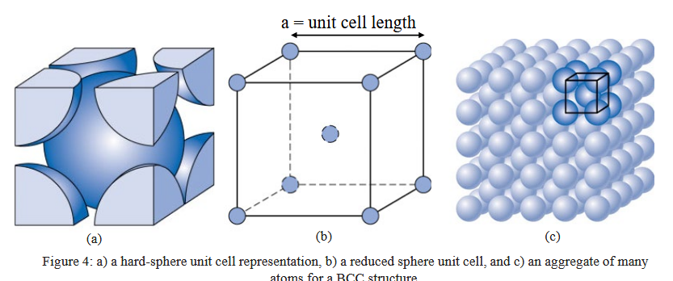

Chromium, Iron (alpha), Tungsten

Note: There’s a gap between the center atom and the faces. So, not equivalent to FCC.

Atoms: 2
Coordination number: 8
Unit cell length: 4R/sqrt(3) (packed on through-center diagonal)
We used diagonal = sqrt(a^2 + a^2 + a^2) = a * sqrt(3)
APF: eh (Gemini: 0.68)

Hexagonal Closed Pack (HCP):

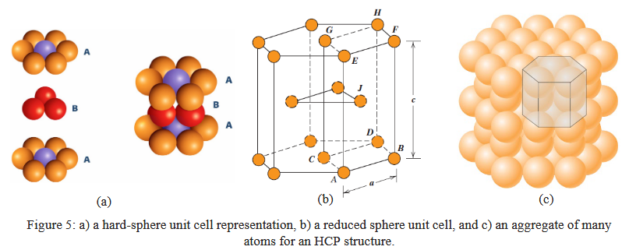

Note: unit cell length is hexagon side length.

Magnesium, titanium, zinc cobalt

Close-packed directions are very important for determining unit cell length!

Atoms: 6
Coordination #: 12
APF: 0.74
Lattice parameter (Gemini): 2R

Theoretical Density

Theoretical density can be determined from unit cell parameters!

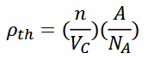
n = number of atoms
A = atomic mass (molar)
V_{C} = unit cell volume
N_{A} = Avogadro’s Number (6.023e23)

Material Properties

Polymorphism = material with one crystal structure

Allotropy = material found in elemental solid

Example: Pure iron:
25 C: BCC
912 C: FCC

Demonstration of changing mechanical, thermal, electrical properties of different crystal structures:
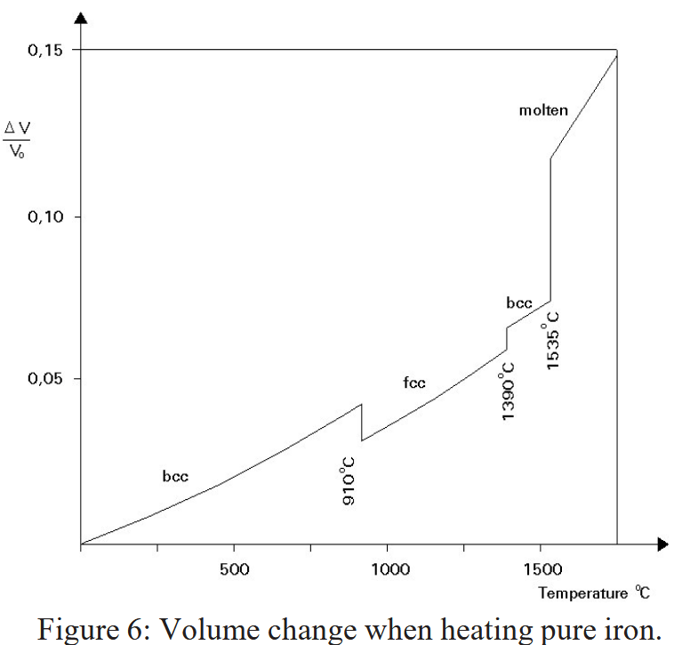

Note: liquids are larger than solids (expect water), so you expect the upward trend.

Jan 12 (L4): Crystal Structures II

Unit cell coordinate system:
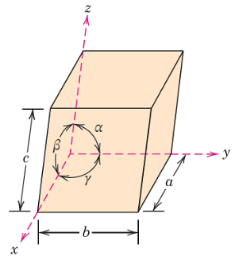

With 6 variables to vary, we get 7 possible combinations. (And some other constraints)

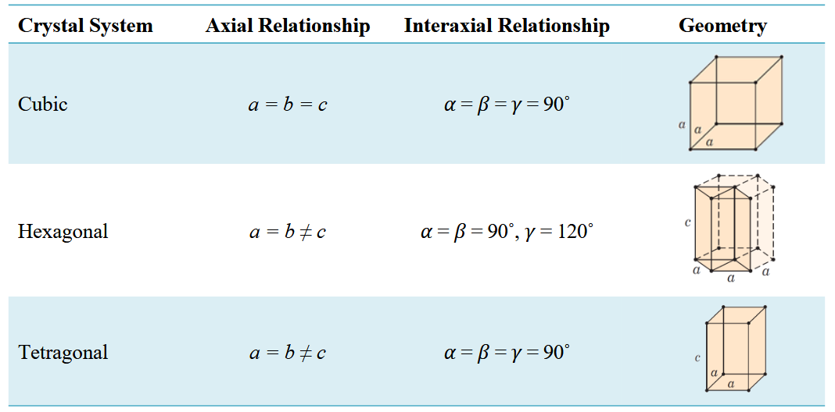
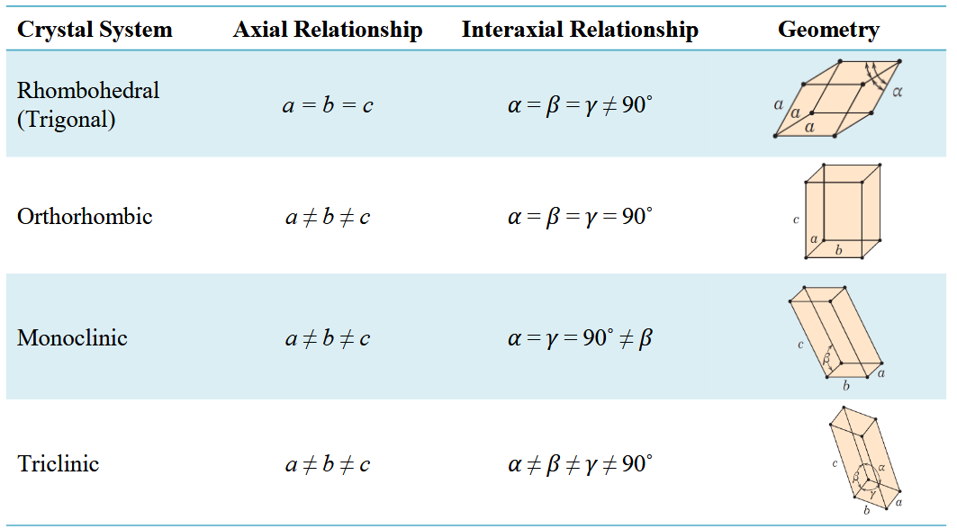

Crystallographic direction: A vector that passes through the origin of the coordinate system used to identify a specific orientation within the lattice.

Determining directions:
- Identify origin & end point
- Determine projections (measure distance the vector travels on each axis)
- Normalize by unit cell dimensions (a,b,c), now you have percentages
- Reduction (multiply / divide to get smallest possible integers)
- Enclosure (use form [uvw])

Eg:
(Correct)
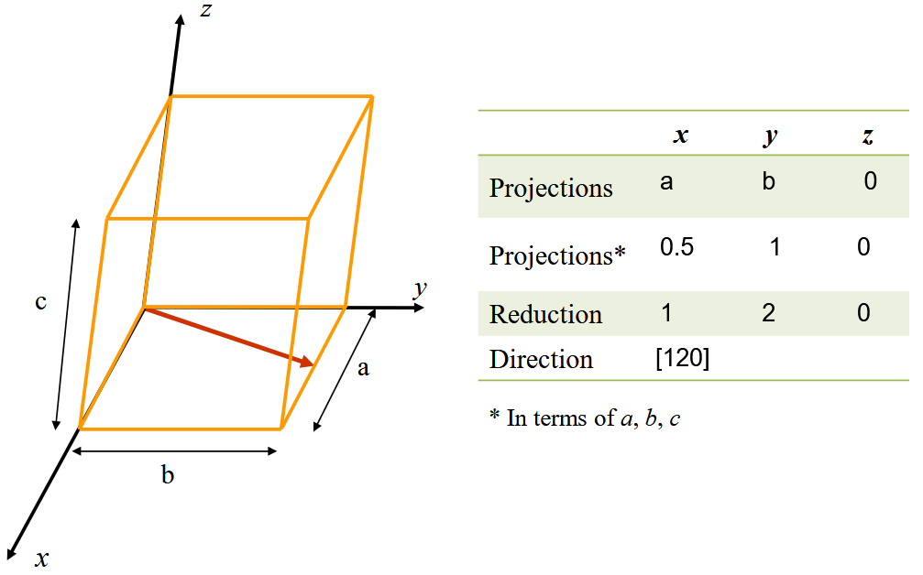

Note: negative numbers are represented with a bar on top. This makes the notation clearer.

Crystallagraphic planes:
- 3 Miller indices specify planes (hkl)
- The indices give the normal vector of the plane

Defining planes:
- Shift Origin (If the plane passes through the origin, move the origin to another unit cell corner or shift the plane). Ie. the plane can’t pass through your starting point.
- Find Intercepts (Find intersection of x,y,z axis in terms of a,b,c (ie. percentages))
- Take reciprocals (1/intercept) (since 1/0 = inf, we can’t use the origin)
- Clear Fractions (Multiply by common factor to get smallest whole integers)
- Notation (Enclose in parenthesis (hkl))

Eg:
(A is likely wrong)
(B correct, A: x=2a/3 y=-b, z=c/2)
Trying again:
- Shift up by ½
- X_intercept now ⅔, y_int = -1, z_int = ½
- Reciprocals: 3/2, -1, 2
- Multiply by 2: [3 -2 4] Correct!
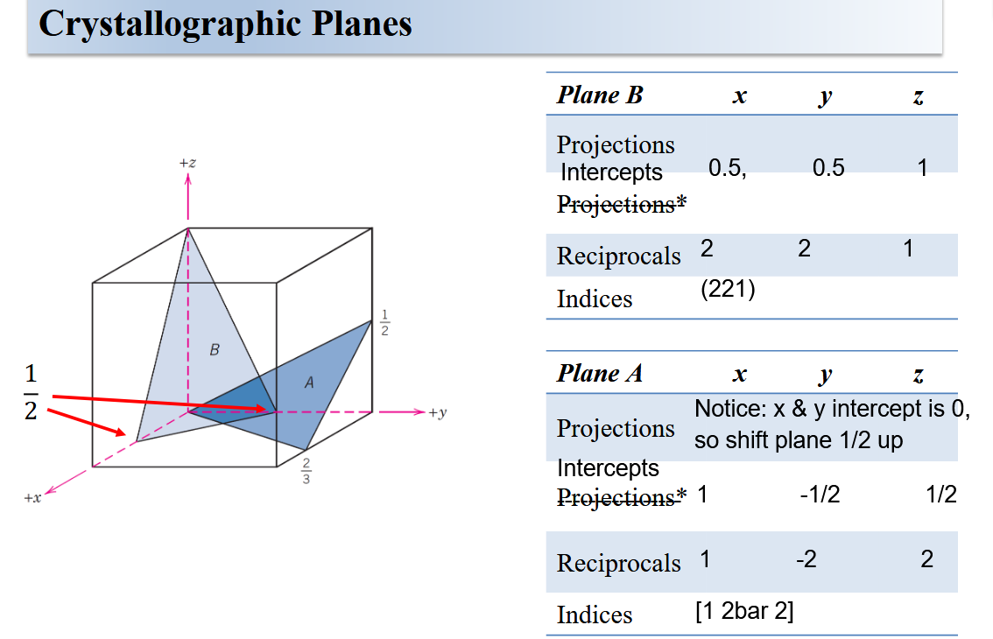

Directions with equal linear density and crystallographically equivalent.
Planes with equal planar density are equivalent.

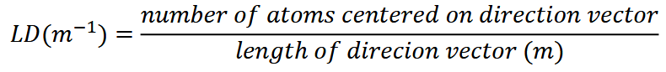
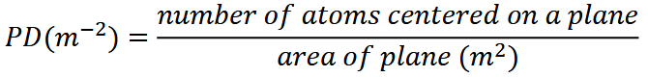

In cubic crystals, each “cardinal” direction is equivalent:
So, they’re represented as a family:
<100>

Notice just the fact that there’s a single 1 and two 2’s means it’s a family. Order does not matter.

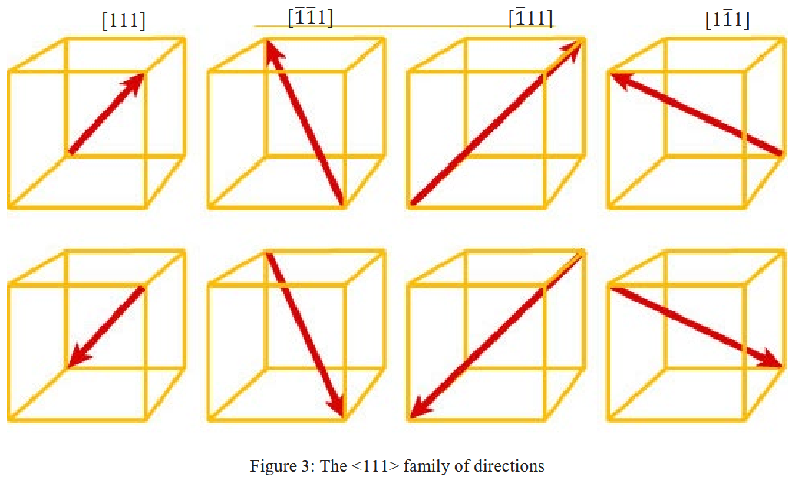

Planes stack, and repeated planes are equivalent to each other
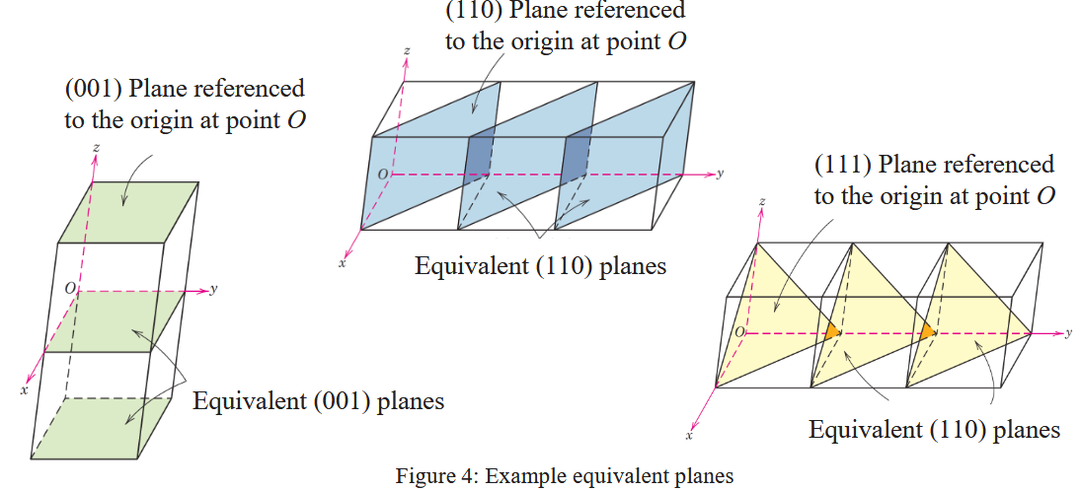

A single crystal is a crystalline solid composed of one crystal.
A polycrystalline material is one made of multiple crystals. See that Veritasium video.

Grains grow while molten, and solidification gives you the final state of the grain boundaries (each different direction collection of atoms is a grain)

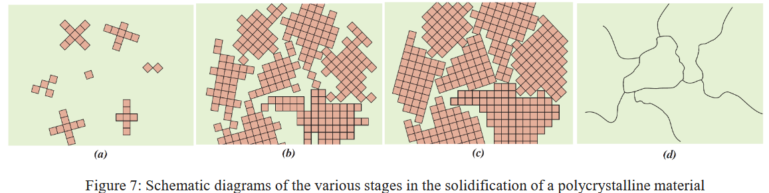

Isotropic = materials whose properties are independent of direction of measurement
Anisotropic = materials whose properties vary by crystallographic direction

Anisotropy increases with decreasing symmetry.

Jan 14 (L5): Imperfections in Solids

Types of imperfections:
- Point defects
  - Interstitials (extra atom)
  - Vacancies (missing atom)
  - Impurity atoms (replacement)
- Line defects
  - Dislocations
- Planar interfaces
  - Grain boundaries
  - Twin boundaries
  - External surface

Vacancy

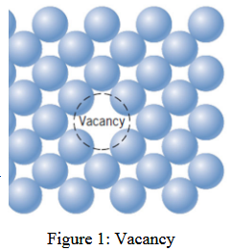

There is an equilibrium of vacancies because they increase entropy.

Equilibrium vacancies formula:
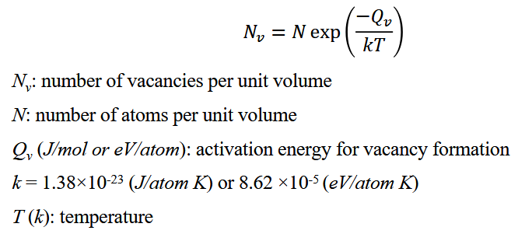

Self-Intersitials

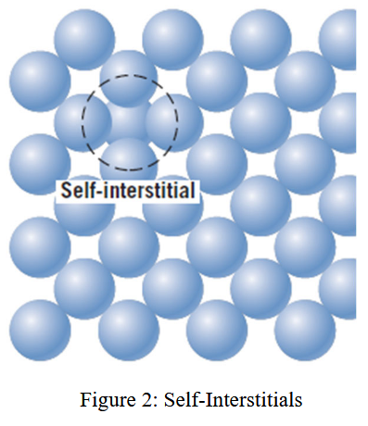

- Interstitial sites are much smaller than the size of the atoms
- Because of the size difference, interstitial atoms cause significant lattice distortion
- They’re also in equilibrium, but far fewer of them

Impurities

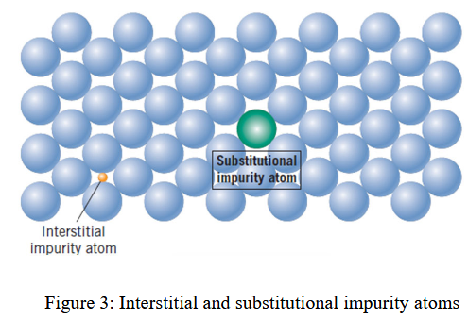

- Impurity atoms are point defects
- Intentionally present in alloys
- Addition of an impurity can form a second phase

Types of impurities:
- Substitutional (requires similar size atom)
- Interstitial (must be much smaller)

The base material is the solvent
The added material is the solute

Degree of solute dissolving into solvent determined by:
- Atomic size factor (<15% size difference)
- Crystal structure (both metal must have the same structure)
- Electronegativity (High electronegativity increases probability of forming intermetallic compounds rather than substitutional solid solutions)
- Valences (Melats dissolve solutes of higher valency better, extra valence electrons stabilize the metallic bond)

The issue with previous chemistry classes is they didn’t give me a mental model that I can apply just by looking at my brass bars.

Linear Defects

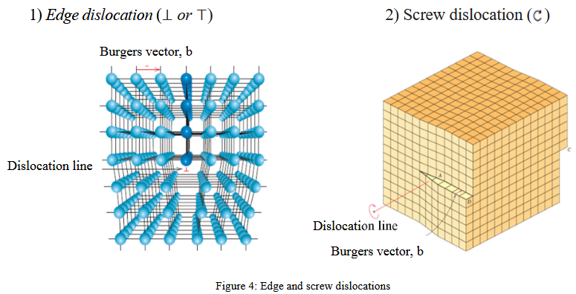

Burgers vector (b):
- Magnitude and direction of lattice distortion
- In metals, b lies along a close-packed direction and has magnitude equal to interatomic spacing (see diagram above)

Edge Dislocation:
- Movement is parallel to the applied force
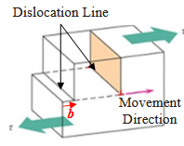

Screw Dislocation
- Movement is perpendicular to the applied force
- Notice the moment
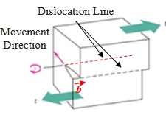

Mix dislocations are the most common, and don’t form straight lines:
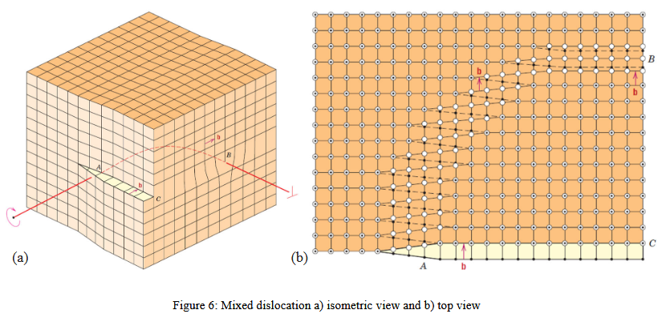

Slips cause plastic deformation.
Slip plane.
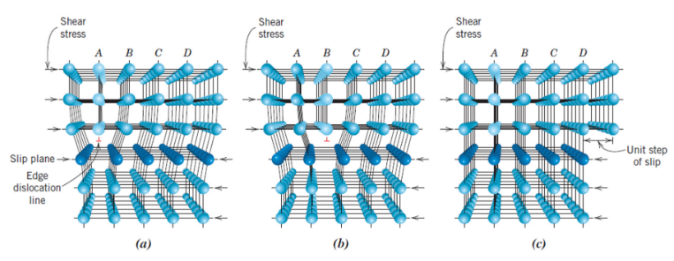

Dislocation density:
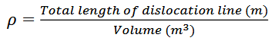

Interfacial defects:
- 2d boundaries that separate regions with different crystal structures or crystallographic orientations
- At external surfaces, surface atoms have fewer neighbors, unsatisfied bonds give us surface energy (J/m2)

Grain Boundaries

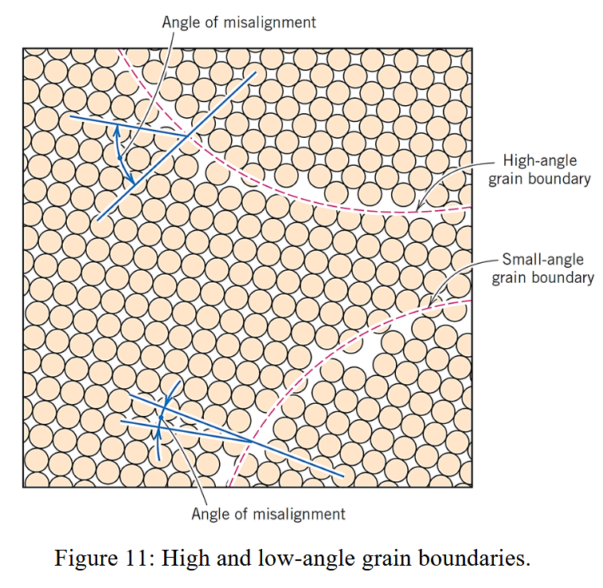

- Grain boundaries more reactive than grains
- Grain boundary energy is a function of degree of misorientation
- Impurity atoms migrate to grain boundaries due to higher energy at grain boundaries

This is polycrystalline brass, showing grain boundaries by which direction they reflect light in (back at us or away?):
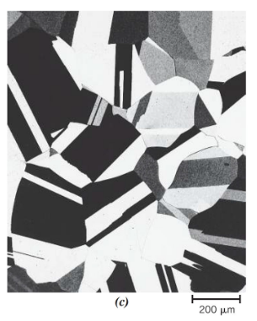
Twin Boundary

- Grains on both sides have mirror symmetry

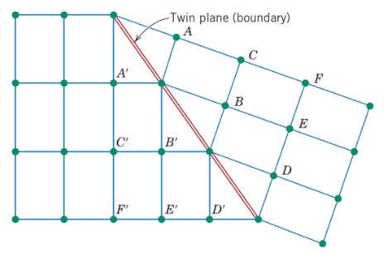

Jan 16 (L6): Mechanical Properties of Materials I - Elasticity

Hooke’s law depends on diameter, thickness, coil count, and material. To normalize for geometric properties we take stress instead of force.

Note the diameter change:
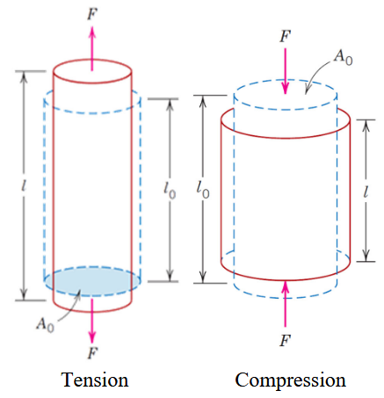

Thomas Young normalized Hooke’s law wrt geometry and got Young’s Modulus (or Elastic Modulus).
E = slope of stress-strain graph
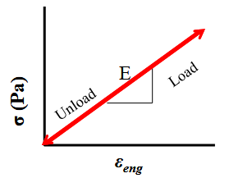

Greater slope on the stress-strain graph implies greater stiffness (less movement per force):
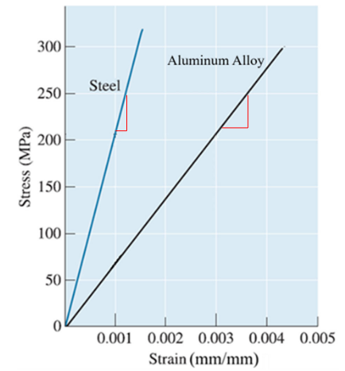

Shear Stress
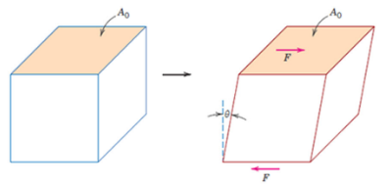

Proportional to stress and sheer area (notice how the definition is different than normal force area)
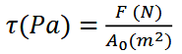

Shear strain is related to the strain angle:

G = Shear modulus
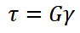

Poisson’s ratio gives you the ratio between longitudinal and lateral strains!
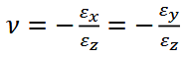

In most materials:
G = 0.4 E
(Shear modulus to Young’s Modulus approximation)

Origin of Elasticity

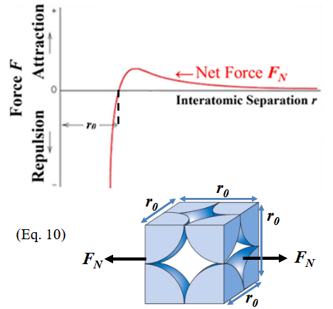

Stress directly relates to strain because of the force vs interatomic separation graph! You’re shifting the equilibrium separation by adding an external force!

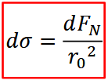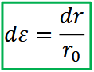

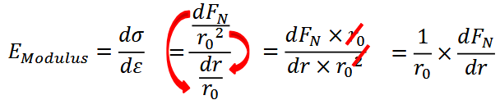

Young’s Modulus is the slope of the force vs interatomic separation graph?! Or, it’s related because of the 1/r₀ term.

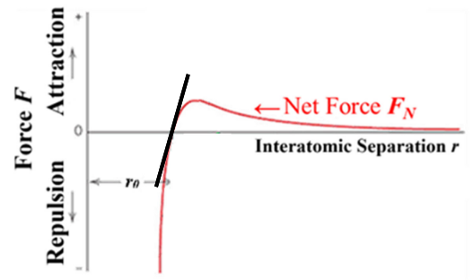

On the graph above, greater slope => greater Young’s modulus

Jan 19 (L7): Mechanical Properties of Materials II - Tensile Test & Plasticity

https://gemini.google.com/share/9e950bd64d07

Tensile Tests

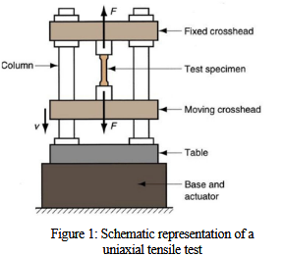

Tensile Tests (Constant strain-rate tests):
- Machine crosshead moves at a constant rate (eg. 1 mm/min)
- Force is continuously measured
- We control strain, and the material responds with a stress
- We record initial area to determine Engineering Stress (in reality, area changes over time)

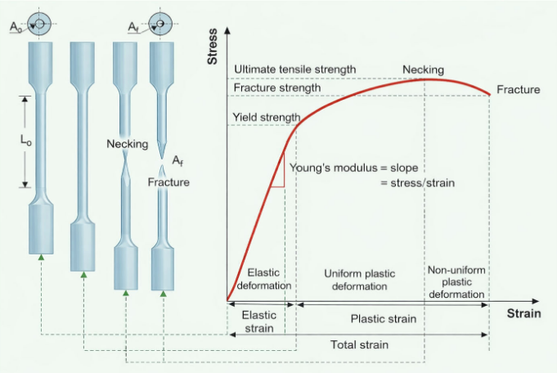

Modulus of Resilience

Modulus of Resilience (U_{r}) is the ability of a material to absorb energy when deformed elastically, and then recover this energy when unloaded.

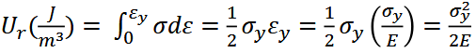

Yield Points

Yield stress = stress at which irreversible deformation occurs
(elastic to plastic transition)
Like yield strength? (a material property)

Plastic deformation occurs because bonds are broken and reformed with different neighbouring atoms.

Proportional limit = when stress-strain graph stops being linear

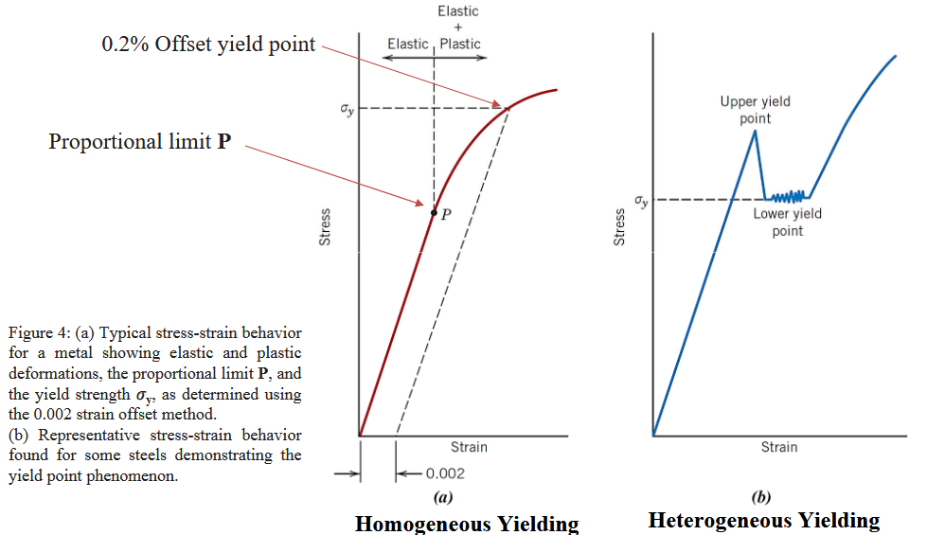

Upper Yield Point:
- Plastic deformation beings
- Dislocations are ripped, materials internal resistance drops

Lower yield point:
- Constant stress as dislocations are continually dislocated

Lower yield point = yield strength

Transition from elastic to plastic behaviour is heterogenous, it doesn’t happen everywhere at once!

Why do we have two yield points:
- Carbon and Nitrogen (in steel) sit in the tension zone in a dislocation (see red in image)
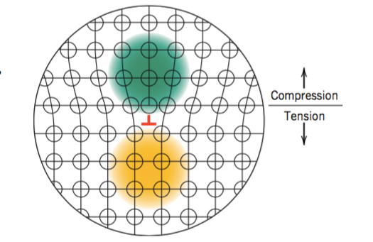
- C and N in the tension zone relieve overall strain of the crystal.
- They provide force to keep the dislocation in place
- Upper Yield Point is when these dislocations first move (C and N forces overcome)
- Once dislocations are moving, a lower stress is required to keep them moving (Lower Yield Point)

Same mental model as static vs kinetic friction.

Luders Bands (Lower Yield Point)

Luders bands are visible dislocations that propagate until they reach another anchored dislocation, then set it off to propagate further.
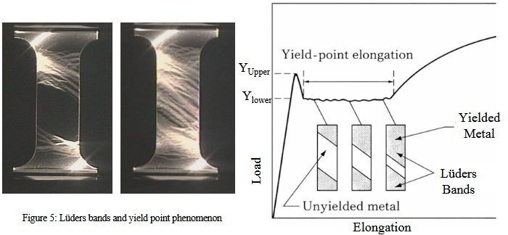

Elastic Recovery (Springback)

Because elastic and plastic deformation occur simultaneously, you get springback!
During unloading, the stress-stain graph follows the same slope down, as Elastic Modulus hasn’t changed.

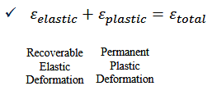
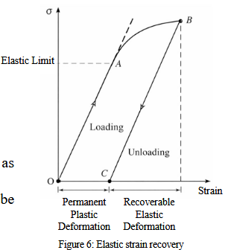

Work Hardening

Once Luders Bands have travelled through the entire material, new dislocations must be created for further strain.

Work Hardening is the process of creating these new dislocations. More dislocations => more force required to move dislocations.

This is why after the yield-point elongation period, the stress-strain graph goes up. Each additional unit of strain requires more stress.

Stiffness = elastic region (stretching bonds)
Strength = plastic region (sliding dislocations)

Slope of the plastic region is called the Tangent Modulus.

UTS & Necking

Ultimate Tensile Strength is the point where the material is getting thinner faster than it’s getting stronger (due to more dislocations).

UTS is when necking begins. Necking is due to cavitation.

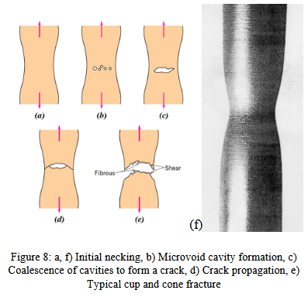

Stiffness, Strength, Steel

Stiffness = slope of elastic region
Strength = peak (before plastic deformation or failure)

Greater carbon content increases yield strength, more impurities in dislocations holding them together.

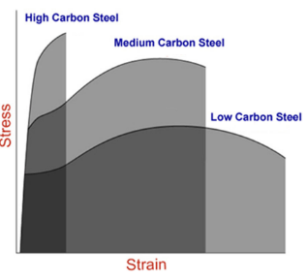

Ductility

Ductility = amount of deformation before fracture

Ductility measured in %Elongation or %Reduction in Area

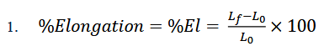

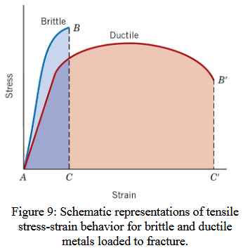

Toughness

Toughness is a material’s ability to absorb energy (plastically deform) before fracturing.

Ie. how much energy can you take before fracturing.

Toughness is the area under the stress-strain curve.

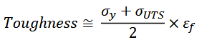
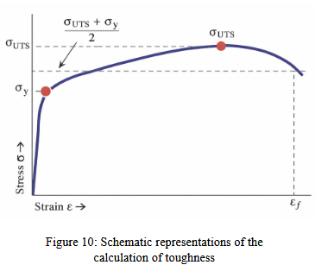

Jan 21 (L8): Mechanical Properties of Materials III - Hardness and True Stress-Strain

Isotropic = property uniform in all directions

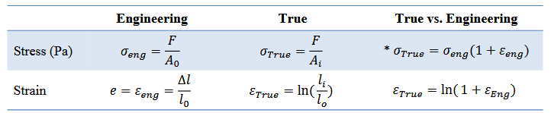

Subscript i = instantaneous
Instantaneous values are hard to find, so we use dL and F.
Engineering values are lower than the true values. More conservative.

Hollomon Equation & Work Hardening

The Hollomon equation gives us stress for the plastic region:
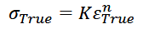

K and n are material-dependent constants. Strength coefficient and work hardening exponent.

Because work hardening is what occurs in the plastic region, the Hollomon equation refers to it.

Hardness
Hardness is a measure of localized plastic deformation (ie. small dent or scratches).

Mohs scale is an old qualitative hardness ranking (check if materials can scratch each other and rank accordingly).

Hardness Tests

Hardness tests use an indenter with controlled force and measure the size of the indentation.

This is a relative method, so comparisons between different methods requires care.

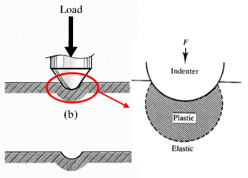

I don’t know why they give full slides on each of these methods. I’ll just remember the indenter and that there is a formula for converting to Hardness Number (HK).

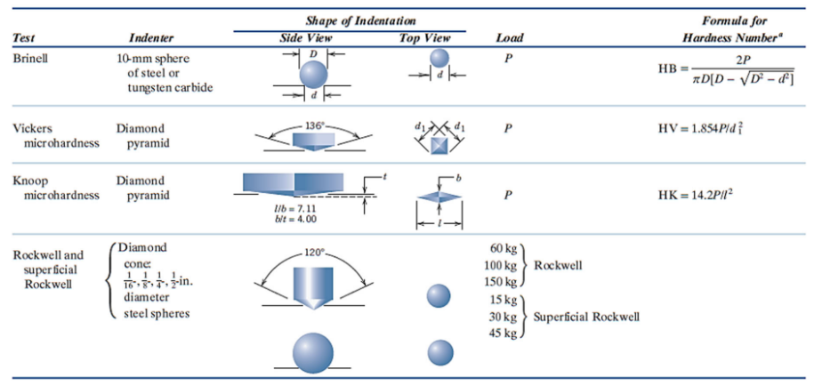

ASTM E140 used to convert between hardness scales.
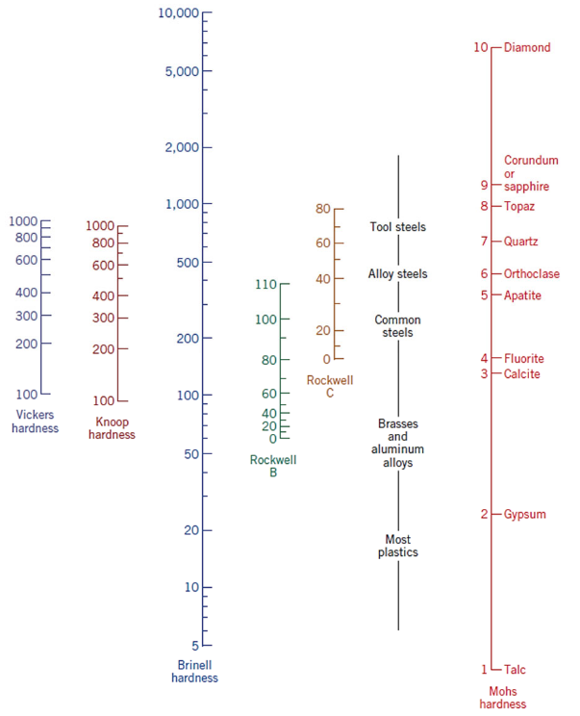

Tensile strength and hardness can be related to each other because both are measures of plastic deformation.

This only works on some metals.

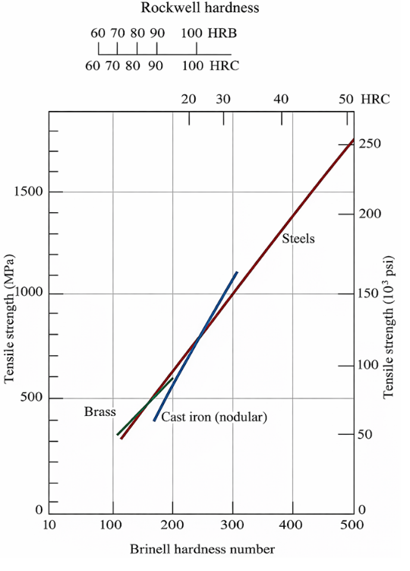

Jan 23 (L9): Dislocations and Strengthening Mechanisms I

https://gemini.google.com/share/6ed75be721d9

Slip plane = crystallographic plane on which a dislocation traverses

Dislocation density = net dislocation length per unit volume

~5% of deformation energy during plastic deformation is stored internally, the rest is heat! The 5% stored is strain energy.

95% of plastic deformation is heat!

It’s possible to have two edge dislocations of opposite sign meeting each other. So, the strain forces in the middle cancel out (you get a plus looking sign instead of T):
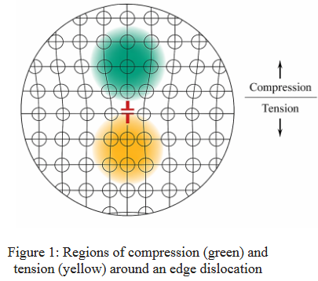

Slip occurs:
- Along the plane with the densest atomic packing (slip plane)
- Along the direction with the highest linear density (slip direction)

Slip planes and directions:
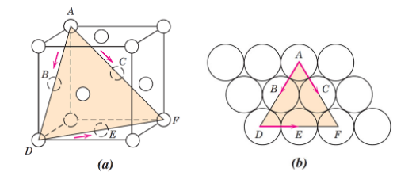

Crystals can have very many slip systems (pairs of planes and directions):
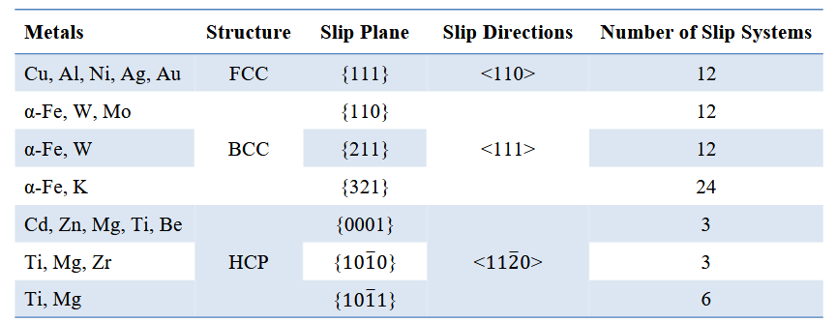

High number of slip systems => High ductility (many more slip systems and dislocations)

Resolved Shear Stresses (tau_r)

Applied stress is redirected into a crystallographic plane in which the atoms can slip. Ie. you can’t deform in any direction, because the crystals likely aren’t in that same orientation.

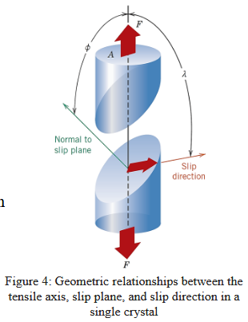

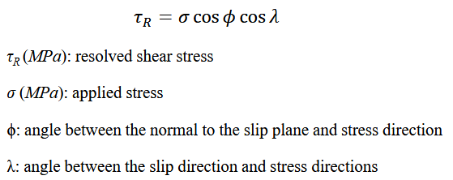

Phi = angle between applied force and slip plane
Lambda: angle between slip direction and applied force

Notice:
If you pull perpendicular to the slip plane, cos(phi) = 0 => shear stress = 0
If you pull perpendicular to the slip direction, cos(lambda) = 0 => shear stress = 0

Critical Resolved Shear Stress
Many slip systems exist in one crystal, and you need to reach a Critical Resolved Shear Stress to initiate plastic deformation, ie. yielding.

Critical resolved shear stress to applied stress required to being yielding:
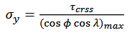

Minimum stress required to start yield occurs at:
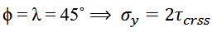
(Which is intuitively obvious, for the case of maximizing the product of two angles cosined)

Notice the parallel slip planes!
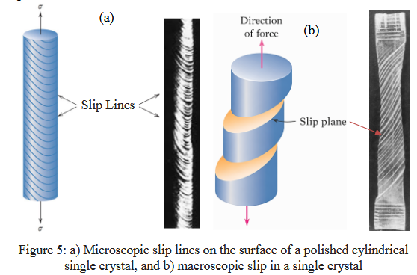

Grain Boundaries

Polycrystalline metals are stronger than single-crystal equivalents? (more boundaries = stronger)

During deformation, grain boundaries usually don’t change. Slip planes extend until they reach the end of a grain.

Reducing mobility of dislocations increases strength. Easily dislocation motion = easier plastic deformation.

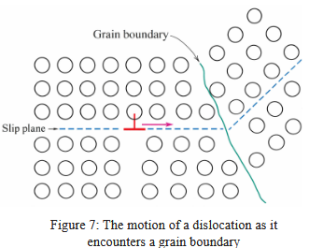

Dislocations can pass into another grain, but that changes the direction of motion and difficulty is correlated with misorientation angle. It also has to pass the disorder of the grain boundary.

Grain Size

Smaller grain size => higher density of grain boundaries

Yield strength to grain size relation:
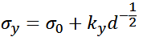
D = average grain diameter
Simga_o, k_y = material constants.
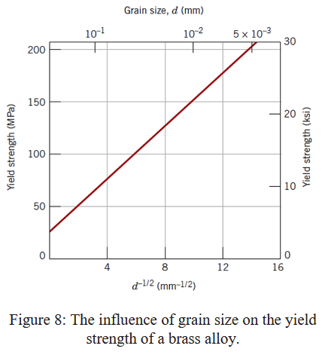

Grain size is controlled by rate of solidification (Higher cooling rate, smaller grain size), plastic deformation and heat treatment.

Solid Solution Strengthening

Alloy impurity atoms produce a substitutional and interstitial solid solution.

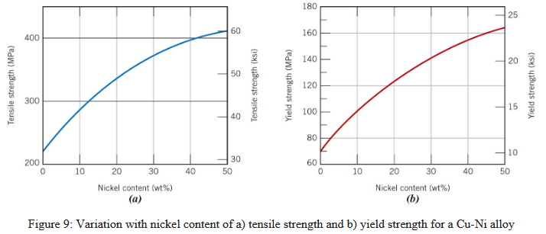

This graph presents promising modelling opportunities.

Tensile and compressive lattice strains are imposed by impurity atoms:
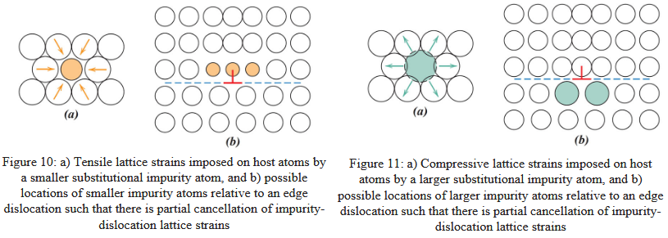

The models here are all very simple, the constants may be difficult, but the model itself should be very doable.
Maybe it could be an exercise in deriving the existence of alloys.

Strain Hardening

Aka work hardening and cold working

It’s called cold working because it’s done at well below melting temperature.

% cold work is the ratio of area:
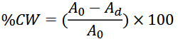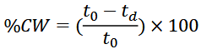

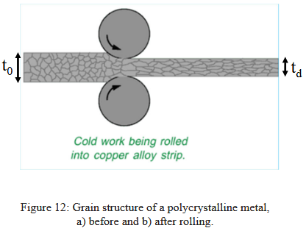

Dislocation Density

Dislocation density increases during cold work:
- Existing dislocations multiply under stress.
- Internal defects are starting points for new dislocations.
- Surface defects (scratches or irregularities) are starting points for dislocation movement.

Dislocation density can increase 1000x after cold working.

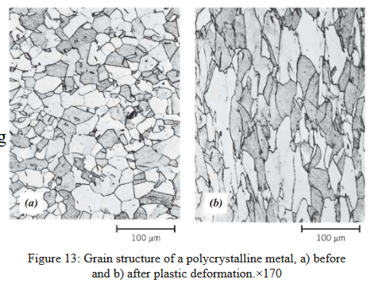

Dislocations & Strain Hardening (more)

Dislocations are repulsive to each other, so more dislocations mean dislocation motion gets harder.

Strain hardening exponent (n) in Hollomon’s equation is the measure of a metal to strain harden:
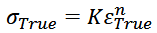

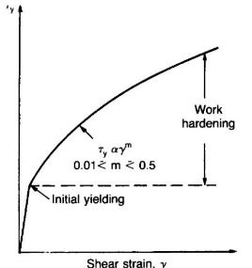

Strength-Ductility Tradeoffs

Strain hardening can increase strength by 3-5x.

As ductility decreases, strength increases.
Ie. the stress-strain graph moves up and to the left.

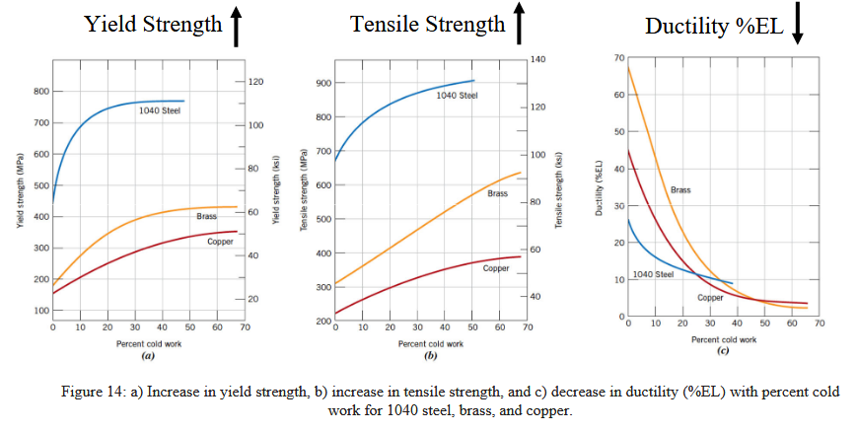

This graph is for low-carbon steel.

All samples have the same Young’s modulus, but different yield strength, UTS, ductility.

So, work hardening doesn’t effect Elastic Modulus (local stretching), it’s only a plastic phenomenon.
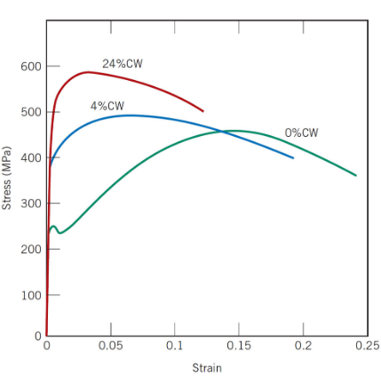
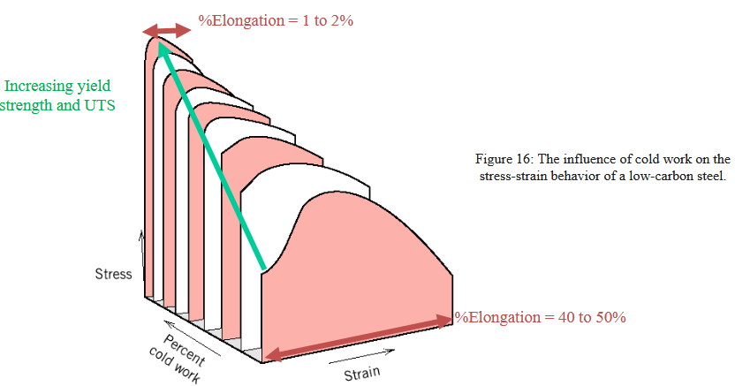

Jan 28: Prelab 1

Brass is Zinc and Copper (next to each other on the periodic table) has substitutional impurities. So, you get homogenous yielding.

Steel has interstitial impurities (Carbon much smaller than Iron), so you get heterogenous yielding with the carbons in the dislocations keeping everything together.

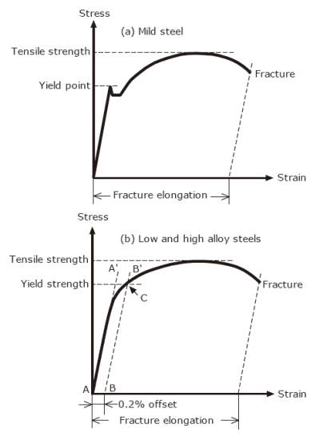

Jan 26 (L10): Dislocations and Strengthening Mechanisms II

Annealing sequential stages:
- Recovery
- Recrystallization
- Grain growth (if heating continues)

Recovery

- Dislocations rearrange and partially annihilate due to atomic diffusion
- Stored internal strain energy relieved
- Physical properties (electrical and thermal conductivity) returned to pre-cold-worked values
- Grain structure and strength change little

Recrystallization

- New stress-free grains with low dislocation density created

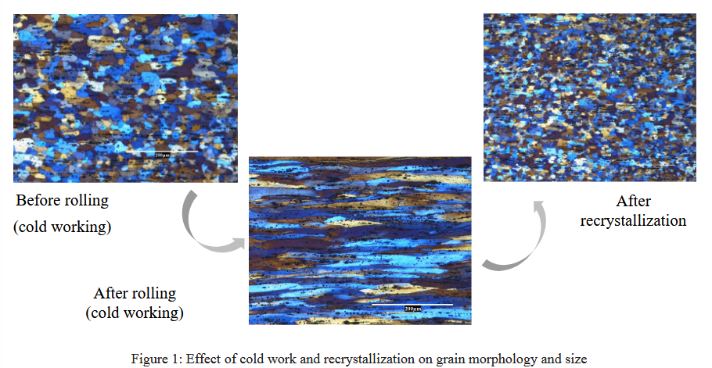

A large difference in internal energy between strained and unstrained material leads to producing a new grain structure.

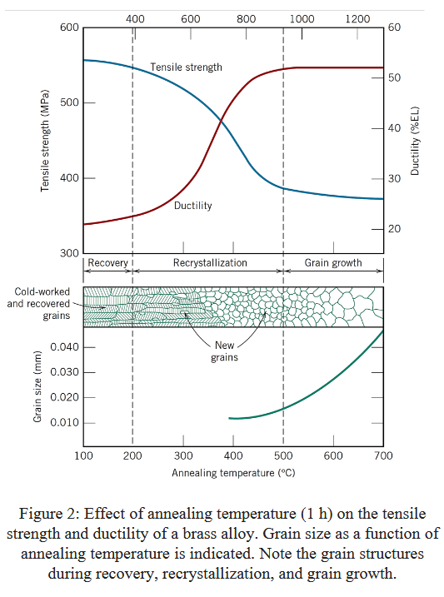

Recrystallization temperature = temp at which recrystallization completes in 1 hour

T_recr usually 0.3-0.5x of T_melt.

Impurity atoms interact at grain boundaries, minimizing their mobility, increasing recrystallization temperature.

Before a critical point, recrystallization is impossible due to a lack of stored strain energy in the crystal.

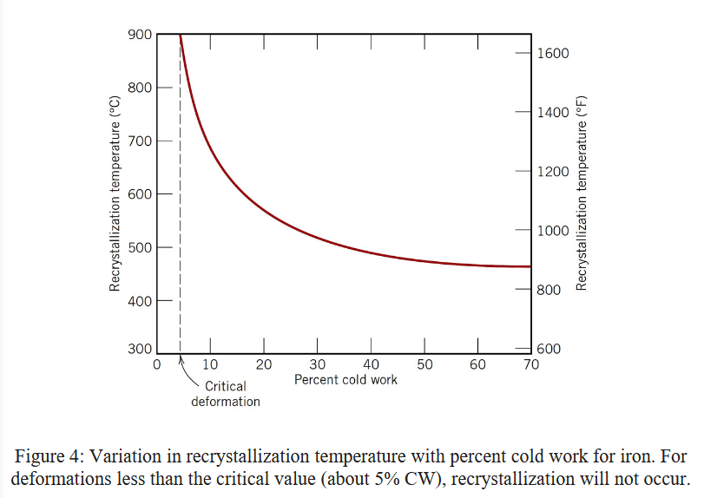

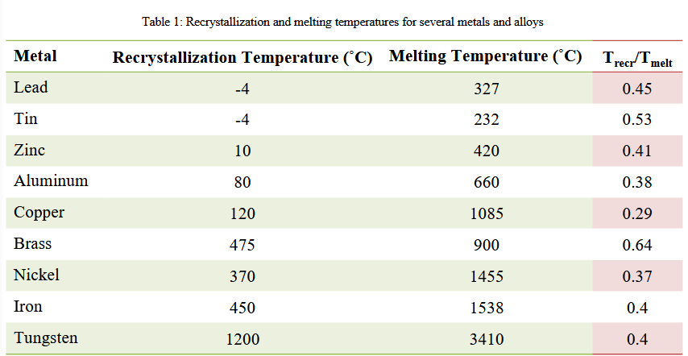

Notice where recrystallization temperature decreases for higher %coldwork:
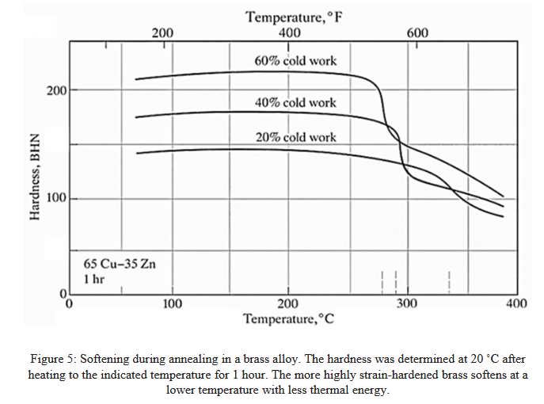

Hot Working

Cold working but with T > recrystallization temperature.

Strain hardening doesn’t occur.

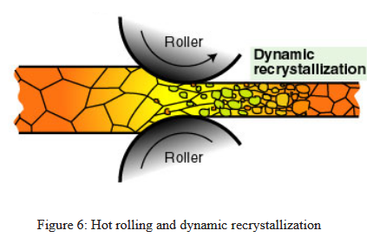

Homogenous temperature gives a measure of the line between hot and cold working:
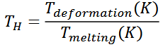

For hot working, dislocations are recovered by recrystallization as fast as they’re introduced by deformation, so you get an equilibrium in dislocation density.

In contrast, cold working would have a positive slope for the plastic part of the curve below.

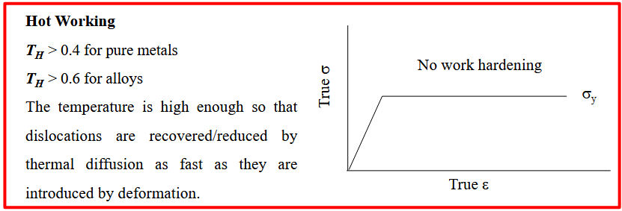

Grain Growth

Grain boundary energy decreases with larger grains, so lower energy overall.

Individual atoms are taken from one grain to another.

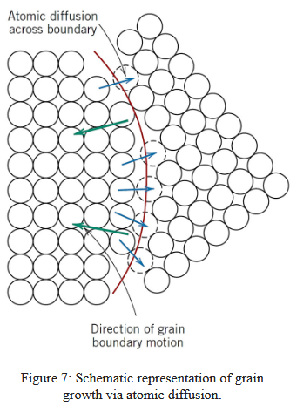

This equation relates grain diameter to numbers you’ll know when given a question:
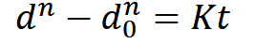

d = grain diameter
t = time
K, n = time-dependent constants

Diffusion rate of grain boundaries / impurity atoms increases with temperature.

Notice rate of a grain diameter expansion is linear (log-log graph) at low temperatures, and non-linear for high temps.

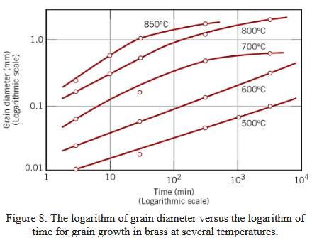

Jan 28 (L11): Failure of Materials I

Brittle materials tend to be “Shiny & Bright”
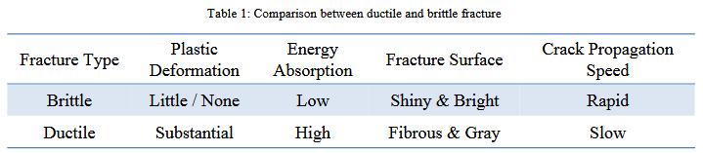

Material failures by degree of ductility:
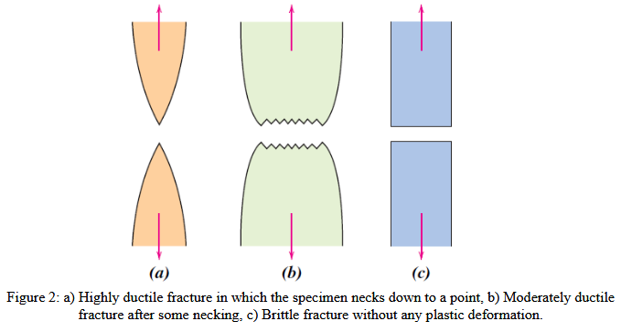

Ductile Fractures

The surface actually looks dimpled and irregular like that!
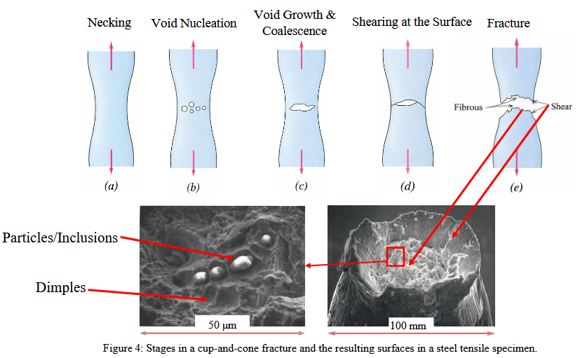

Microvoids are formed after necking, followed by an elliptical crack, then a fracture to the outer surface (at about a 45 degree angle?! See above).

The above diagram is a cup-and-cone fracture (figure 4e) because one half is the cup and another a cone, mainly due to that 45 degree angle fracture.

Cracks don’t necessarily form at grain boundaries:
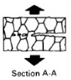

Dimple shape is governed by loading mode:
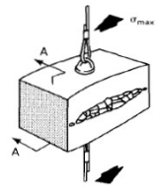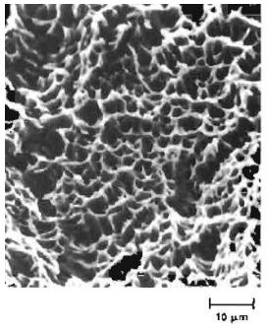

And:
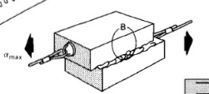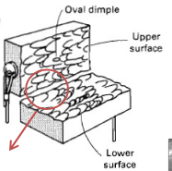

And:
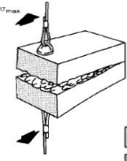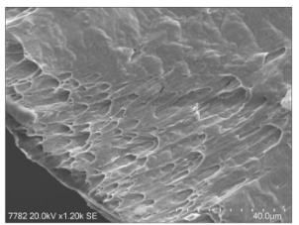

Scanning Electron Microscope!

Brittle Fractures

Brittle Fractures have flat surfaces:
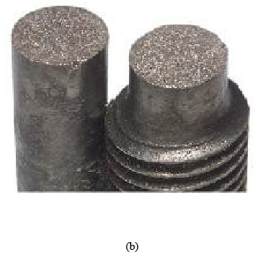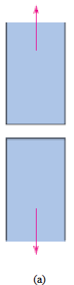

Ridges are formed by brittle failures, in two primary modes, that are visible to the naked eye.

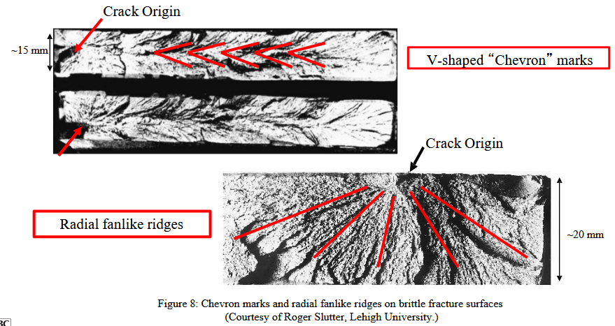

Intergranular (grain boundaries) vs. Transgranular (through grain) brittle fractures.

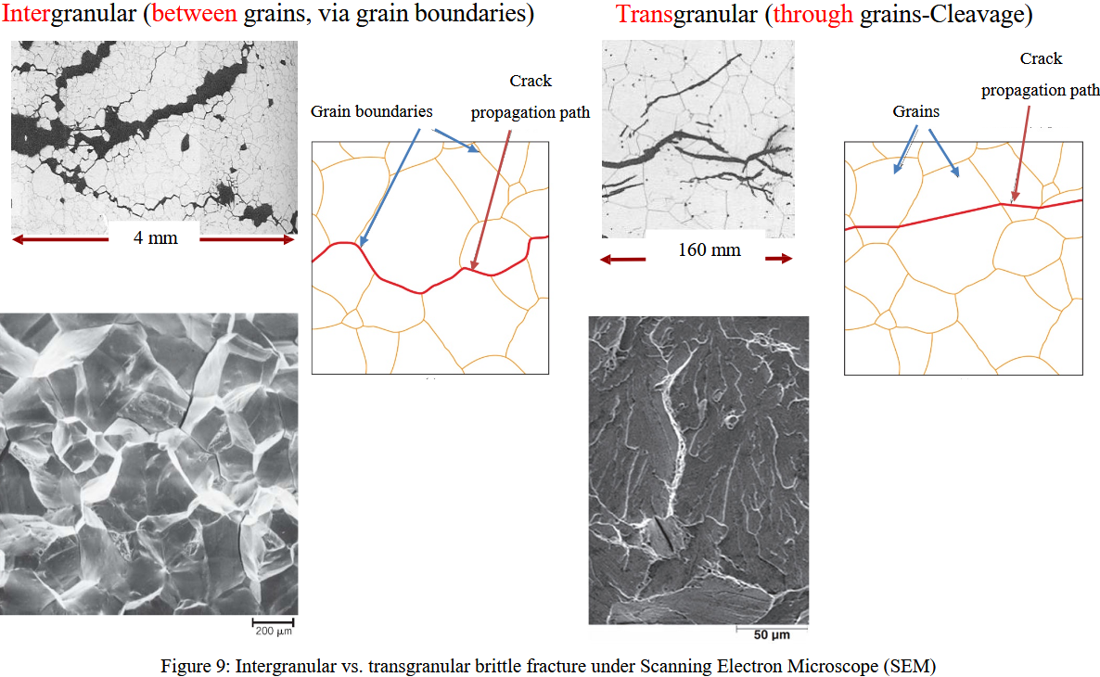

Cracks / Defects

Theoretical cohesive strength = peak of interatomic force graph. Usually this is far higher than UTS.

DaVinci found that longer wires could handle lower load (all else equal) because larger samples contain more flaws.

Tiny defect-free metallic whiskers or silica fibers can get close to theoretical strength values.

Griffith Theory:
A crack will propagate when the energy released by extending the crack is => energy required to create new fracture surfaces.

Stress is concentrated at defect edges.

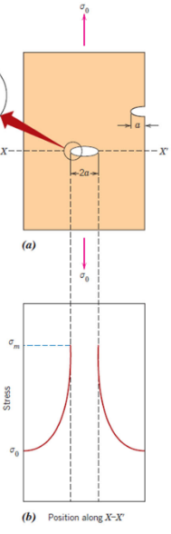

To model cracks, we assume:
- Crack is an elliptical hole
- Printed perpendicular to the applied stress

Approximate maximum stress at crack tip:
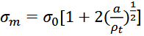

p_{t} = radius of curvature of crack tip
sigma_0 = applied stress
a = length of surface crack (seen in diagram above)

For long micro-cracks with small curvature tip radius, we can approximate it as:
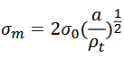

Hence, stress concentration factor becomes:
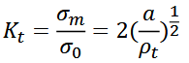

These defects are called “stress raisers”
- Macroscopic internal discontinuities
  - Voids
  - Inclusions
- Sharp corners
- Scratches
- Notches

Stress raisers are far more significant in brittle than ductile materials, as brittle materials can’t plastically deform.

Griffith’s theory allows prediction of critical stress required for crack propagation:
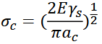

sigma_c = critical stress
gamma_s = specific surface energy (Jm^-2)
a_c = half of the critical length of an internal crack (size before it grows uncontrollably)

Feb 4 (L12): Failure of Materials II

Cracking Modes

- Opening (Tensile)
- Sliding (Shear)
- Tearing (Torsion)

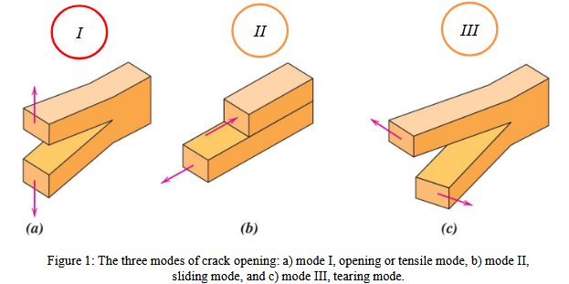

Linear Elastic Fracture Mechanics model gives us:
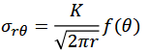
K is the stress intensity factor

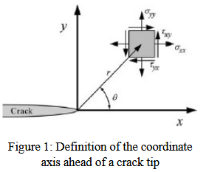

Determining Stress Intensity Factor
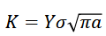

Y = crack parameter (Crack size, geometries, opening mode) (dimensionless)
a = half internal crack length

Determining Y

Heuristics:
- Infinite width crack, Y = 1
- Edge crack: Y ~= 1.1

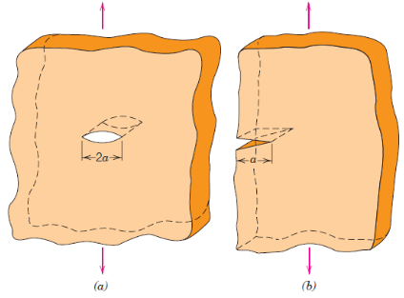

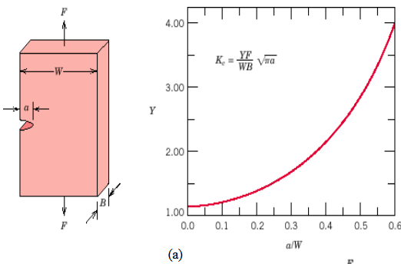
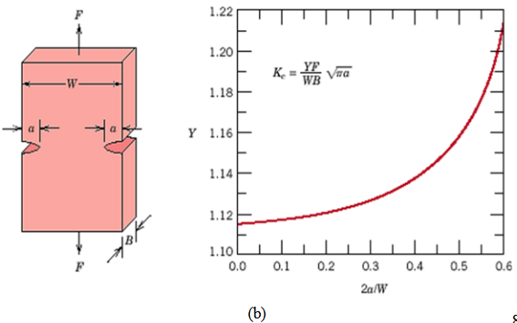

Fracture Toughness

Critical Stress Intensity Factor (K_{C}) is the K at which a crack propagates.

Fracture Toughness = ability to withstand a load if a material has a flaw

Notice K_{C} depends on thickness and eventually reaches a constant value.

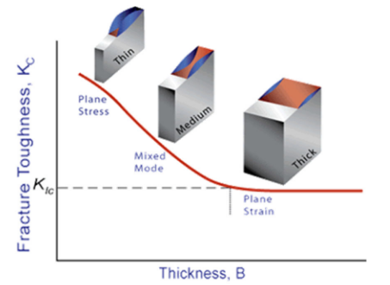

Plane Strain Fracture Toughness (K_{IC}) = minimum value of K_{C} (in the limit)

Many definitions given with zero context.

Low K_{IC} => vulnerable to brittle failure

Finer grain size => higher K_{IC}

I FUCKING LOVE LIBERTY SHIPS I FW HENRY KAISER

Impact Tests

These severe conditions cause abrupt failures:
- Low temperature: dislocation movement harder, less stretch
- Hain strain rate (impact): dislocations don’t have time to move
  - This would be fun to attempt to model!
- Tri-axial state of stress: forces in multiple directions so shear can’t occur and brittle failure occurs

V-Notches cause tri-axial stress states because it concentrates it in a single point.
The hammer causes a high strain rate.
Temperature is controlled.
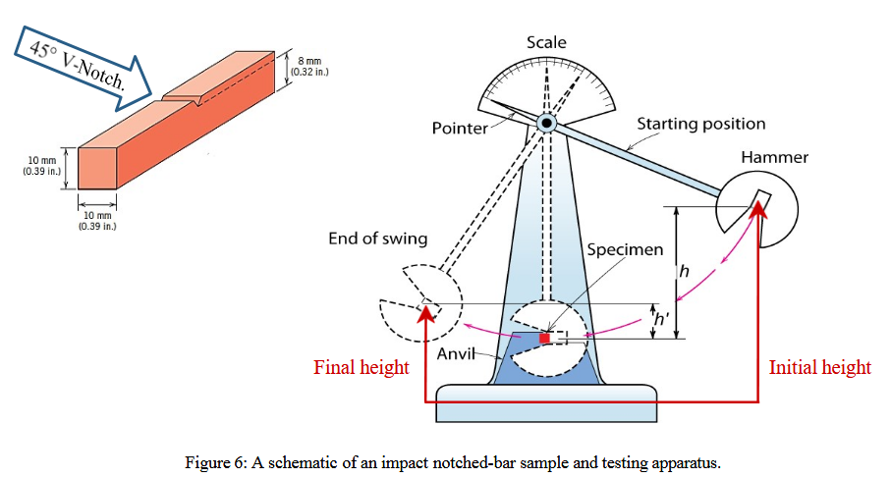

Liberty Ships

Slides tell me:
- Made of mild steel (Thought to be ductile)
- Welding used instead of rivets

Gemini tells me:
- 1,500 / 2,700 Liberty ships during WWII developed cracks
- S.S. Schenectady snapped in half (How do you name 2,700 ships?!)

- Mild steel in a BCC crystal structure used.
- Temperature in the North Atlantic dropped below the Ductile-to-Brittle Transition Temperature
- Corners of doors and hatches were square, acting like a V-notch in an impact test and creating a tri-axial state of stress.
- Welding allowed crack propagation

Nothing matters other than:
- Cold North Atlantic

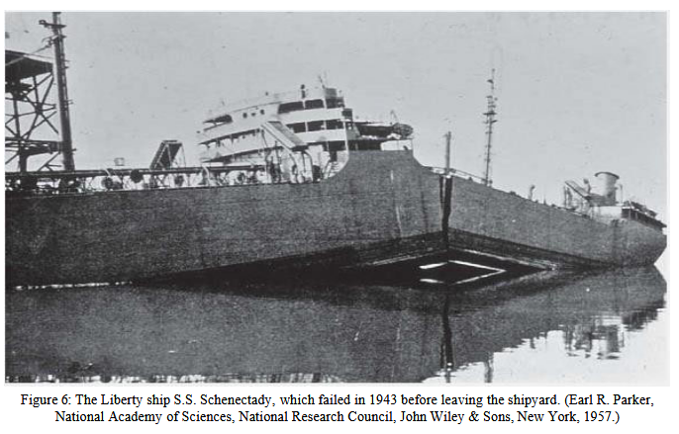

Ductile-to-Brittle Transition

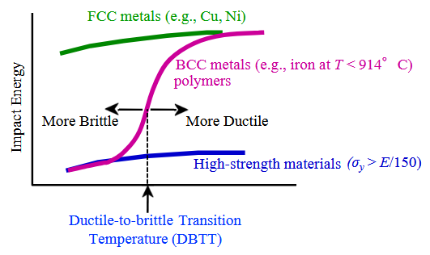

Impact surfaces of impact test specimens:
- Fibrous surface = ductile failure
- Granular surface = brittle failure

Notice the failures get more brittle at lower temperature!!!!
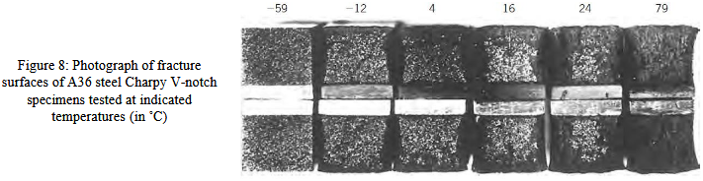

Factors influencing DBTT:
- Allow composition (Increased carbon content & strength of steel = higher DBTT)
- Microstructures (lower grain size = lower transition temp)

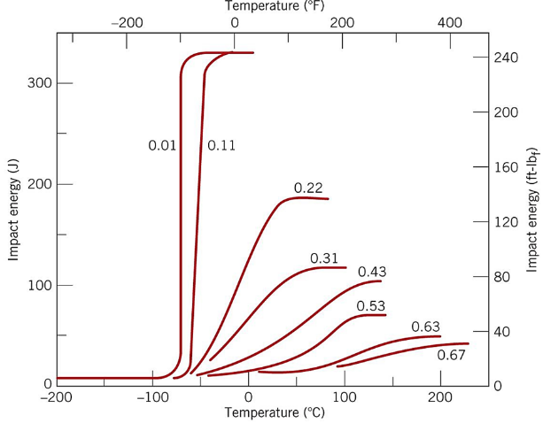
% Carbon content shown above.

Feb 6 (L13): Failure of Materials III

Feb 9 (L14): Failure of Materials IV

Feb 11 (L15): Phase Diagrams I

Feb 13 (L16): Phase Diagrams II

Feb 23 (L17): Phase Diagrams III

Feb 25 (L18): Process of Metal Alloys I

Feb 27 (L19): Processing of Metal Alloys II

Mar 2 (L20): Ceramics I

Mar 4 (L21): Ceramics II

Mar 6 (L22): Composites I

Mar 9 (L23): Composites II

Mar 11 (L24): Composites III

Mar 13 (L25): Polymers I

Mar 18 (L26): Polymers II

Mar 20 (L27): Polymers III

Mar 23 (L28): Corrosion and Degradation of Metals I

Mar 25 (L29): Corrosion and Degradation of Metals II

Mar 27 (L30): Corrosion and Degradation of Metals III

Mar 30 (L31): Electrical Properties I

Apr 1 (L32): Electrical Properties II

